Final Project Report

VU Proctors-Diary



Project Supervisor

Tooba Ahmad

Submitted By

bc230410624

Software Projects & Research Section,
Department of Computer Sciences,
Virtual University of Pakistan


CERTIFICATE

This is to certify that Mehak (bc230410624) has worked on and completed their Software Project at Software & Research Projects Section, Department of Computer Sciences, Virtual University of Pakistan in partial fulfillment of the requirement for the degree of BS in Computer Sciences under my guidance and supervision.

In our opinion, it is satisfactory and up to the mark and therefore fulfills the requirements of BS in Computer Sciences.

Supervisor / Internal Examiner

Tooba Ahmad
Supervisor,
Software Projects & Research Section,
Department of Computer Sciences
Virtual University of Pakistan

___________________
(Signature)

External Examiner/Subject Specialist
<<External Supervisor Name>>

___________________
(Signature)

Accepted By:

_____________
(For office use)

EXORDIUM

In the name of Allah, the Compassionate, the Merciful.

Praise be to Allah, Lord of Creation,
The Compassionate, the Merciful,
King of Judgment-day!

You alone we worship, and to You alone we pray for help,
Guide us to the straight path

The path of those who You have favored,

Not of those who have incurred Your wrath,
Nor of those who have gone astray.

DEDICATION



IN THE NAME OF ALLAH THE MOST BENIFICIENT THE MERCIFUL

I dedicate this Project to my beloved
Father & Teachers
And
To the Loving memory of my Mother
And also
To my brothers & sisters.
You have successfully made me the person I am becoming
You will always be remembered.

ACKNOWLEDGEMENT

Foremost, I am highly grateful to Allah for His blessing that continue to flow into my life, and because of You, I made this through against all odds.

With a great pleasure I would like to acknowledge the support, assistances and contribution made by individuals from the beginning of the Project, providing me access, data and information, to the writing process until the completion of this project.

First of all, I want to give thanks to our project supervisors Asif Hussain for the access and assistance in order to make my project possible.

Second I would like to thank all the Mater program staff, thank you all for the assistance and constructive discussions we had during the entire courses

PREFACE

This project report has been prepared in fulfillment of the requirements for the BS in Computer Science.

For preparing of the project report, I have closely studied the VU Proctors-Diary of certain compounds to get the knowledge of the data requirements that will be used successfully to protect any entrance breaches.

I have also studied the software that was required for this project coding like, HTML CSS PHP and databases.

This project started with to final coding I which have given me the ability to understand the concept of programming and move me forward smoothly.

I am very thankful to my supervisors who have helped me to complete this project and I really appreciate all his efforts and support.

I am also very thankful to Virtual University, Pakistan and all the staff.

TABLE OF CONTENTS

Chapter No. 1
Gathering & Analyzing Info 9

1.1 Introduction: 10
1.2 Purpose: 10
1.3 Scope of Project: 10
1.4 Definitions, Acronyms and Abbreviations 11
1.5 Project Requirements 11
1.5.1 Functional Requirements: 11
1.5.2 Non-Functional Requirements: 11
1.6 Use Cases and Usage Scenarios: 14
1.6.1 Use Case Diagram: 14
1.6.2 Usage Scenarios: 15
1.7 Development Methodology: 18
1.7.1 Chosen Methodology: 18
1.7.2 Reasons for Chosen Methodology: 18
1.7.3 Work Plan (Gantt Chart): 21
1.7.4 Project Schedule (Submission Calendar): 22

Chapter No. 2
Designing the project 23

2.1 Introduction: 24
2.2 Purpose: 24
2.3 Scope: 24
2.4 Definitions, Acronyms and Abbreviations: 24
2.5 Architectural Representation (Architecture Diagram) 24
2.6 Dynamic Model: Sequence Diagrams: 26
2.7 Object Model/Logical Model: Class Diagram: 31
2.8 Database Model (Database Diagram): 31
2.9 Graphical User Interfaces: 32

Chapter 3
Development 35

3.1 Development plan (Architecture Diagram) 36

Chapter 1

Gathering & Analyzing Info

Introduction:

The first draft of the Software Requirements Specification (SRS) document has been prepared for the project. This document highlights the system's primary goals and scope. It contains: Scope, Use Case Diagram, Usage Scenarios,

Chosen Methodology, Gantt Chart

Purpose:

The platform connects book lovers, helps build a community, and supports sustainability by encouraging the reuse of books. It is designed to be easy to use and accessible on devices like computers, tablets, and smartphones

Scope of Project:
The VU Proctors-Diary is a web-based platform designed to streamline the scheduling, communication, attendance, payments and performance tracking of exam proctors (invigilators and Superintendents) across Virtual University examination centers.

Definitions, Acronyms and Abbreviations

• HTML (Hyper Text Markup Language)
• CSS (Cascade Styling Sheet
• DBMS (Database Management System)
• SQL (Structured Query Language)

Project Requirements

Functional Requirements:

1. Secure Login: Proctors and admins can log in with verified credentials.

2. Personalized Dashboard: Proctors access a dashboard with assigned tasks and exam information after logging in.

3. Schedule Management: Admins can create and update proctoring schedules.

4. Daily Reporting: Proctors submit daily reports and observations about exams.

5. Incident Reporting: Proctors report any irregularities during exams.

6. Attendance Tracking: Proctors record their attendance and students' attendance.

7. Notification System: Alerts and updates are sent between proctors and admins.

8. Report Generation: Admins generate and download proctor activity summaries.

9. Search Functionality: Users search previous entries by date, proctor, or exam center.

10. Role-Based Access: Different permissions for Admin and Proctor roles.

2.2 Non-Functional Requirements:

Non-functional requirements are the criteria that define how a system should behave, rather than what it is supposed to do. Unlike functional requirements, which describe specific system functions, non-functional requirements define aspects like performance, security, usability, reliability, and scalability.

- Usability
The system must provide a user-friendly and intuitive interface for students, faculty, and admin users. It should be easy to navigate with minimal training.
- Performance
The system should respond quickly to user actions, ensuring smooth operations even under heavy usage, especially during submission and evaluation periods.
- Scalability
The system should be scalable to accommodate a growing number of users, research papers, and roles without performance degradation.
- Reliability
The system must ensure high availability and consistent functionality to avoid disruptions during critical academic activities like paper submission or evaluation.
- Security
Strong authentication, role-based access control, and secure file uploads should be implemented to protect sensitive data and prevent unauthorized access.
- Maintainability
The codebase and database structure should be modular and well-documented to allow easy updates, debugging, and future enhancements.
- Compatibility
The system must be compatible across various browsers (Chrome, Firefox, Safari, etc.) and devices (desktop, tablet, mobile).
- Accessibility
The system should comply with accessibility standards (e.g., WCAG) to support users with disabilities, including screen reader compatibility and keyboard navigation.
- Data Privacy
Personal and academic data must be handled in compliance with privacy laws and regulations. Data should be stored securely and only accessible to authorized users

Use Cases and Usage Scenarios:

Use Case Diagram:
A Use Case Diagram visually represents the interactions between users (actors) and a system, highlighting the system's functionalities (use cases) within its defined boundaries. It shows how actors interact with specific use cases through associations and may include relationships like "include" for mandatory actions and "extend" for optional behaviors. This diagram is used to capture system requirements, communicate functionality to stakeholders, and guide the system's design by focusing on what the system should do, not how it does it.

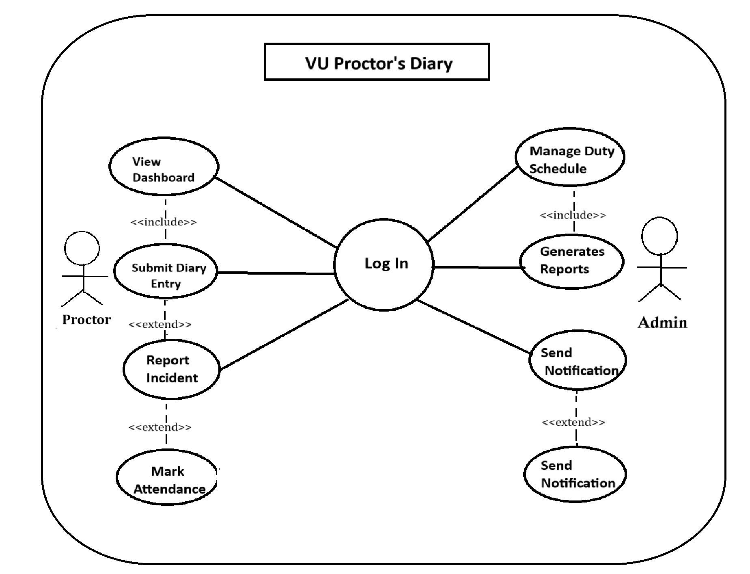

Usage Scenarios:
Usage scenarios outline how a product, service, or technology is applied to meet specific needs or solve problems in real-world contexts. They highlight key users, their goals, and the solution’s impact.

Use Case: Log in

Use Case Title | Login
Use Case ID | UC-01
Actions | User enters ID and password → System validates → Access granted
Description | Allows Proctor/Admin to securely log in to the system.
Alternative Paths | Invalid credentials → show error message
Pre-Conditions | User must be registered
Post-Conditions | User is logged in
Author | bc230410624
Exceptions | Network error, incorrect credentials

Use Case: View Dashboard

Use Case Title | View Dashboard
Use Case ID | UC-02
Actions | System loads dashboard with duties, diary, and reports
Description | Displays summer view of of all assigned responsibilities
Alternative Paths | User skips to another module directly
Pre-Conditions | User is logged in
Post-Conditions | Dashboard Loaded
Author | bc230410624
Exceptions | Dashboard failed to load due to backend error

Use Case: Submit Diary Entry

Use Case Title | Submit Diary Entry
Use Case ID | UC-03
Actions | Select Session → Select Details → Submit
Description | Proctor records details of exam session, students' behavior, and environment.
Alternative Paths | Auto-save draft if disconnected.
Pre-Conditions | Proctor is locked in
Post-Conditions | Diary and Receive
Author | bc230410624
Exceptions | Validation error, server timeout

Use Case: Report Incident

Use Case Title | Report Incident
Use Case ID | UC-04
Actions | Select Incident Types → Enter Details → Submit
Description | Allows proctors to report any cheating or misconduct during the exam.
Alternative Paths | Cancel or discard report.
Pre-Conditions | Proctor must have a diary entry.
Post-Conditions | Incident saved and flagged.
Author | bc230410624
Exceptions | Missing required fields upload error.

Use Case: Mark Attendance

Use Case Title | Mark Attendance
Use Case ID | UC-05
Actions | Select Incident Types → Enter Details → Submit
Description | Let's record student attendance during the exam
Alternative Paths | Partially save attendance
Pre-Conditions | Session must be active
Post-Conditions | Attendance recorded
Author | bc230410624
Exceptions | Network failure, form error

Use Case: Manage Duty Schedule

Use Case Title | Manage Duty Schedule
Use Case ID | UC-06
Actions | Admin selects proctor and date → Assign duty → Save
Description | Enables admin to assign examination duty to proctors.
Alternative Paths | Edit existing schedule.
Pre-Conditions | Admin must be logged in.
Post-Conditions | Duty schedule updated.
Author | bc230410624
Exceptions | Data conflict, proctor unavailable.

Use Case: Generate Reports

Use Case Title | Generates Report
Use Case ID | UC-07
Actions | Select report types → Choose filter date → Generate
Description | Admin generates PDF extra reports for diary entries, attendance, or incidence.
Alternative Paths | Switch report types.
Pre-Conditions | Admin must be logged in.
Post-Conditions | Report generated and exported.
Author | bc230410624
Exceptions | No data found, export fails.

Use Case: Send Notification

Use Case Title | Send Notification
Use Case ID | UC-08
Actions | System triggers alert of incidents → Sends emails, SMS
Description | System notify admin instantly submits an incident report.
Alternative Paths | Notification delayed.
Pre-Conditions | Incident must be submitted.
Post-Conditions | Alert sent to admin.
Author | bc230410624
Exceptions | Message delivery failed, contact info invalid.

Adopted Methodology:

Let’s see what the word methodology really means.
The branch of philosophy that analyze the principles and procedures of inquiry in a particular discipline and here in software development, methodology is a predefined standard procedure to accomplish a development goal successfully. Software engineering discipline provides a number of methodologies for project management.

Existing Methodologies:

We have studied a number of methodologies in our Software Engineering-II course such as Build & Fix Model, Waterfall Model, Rapid Prototyping Model, Integrated Waterfall and Rapid Prototyping Model, Rapid Application Development Model, Synchronize & Stabilize Model and Spiral Model. Of course, there are many other models available in the market like Feature Driven Development, Extreme Programming (XP) Model, and Dynamic System Development Model and SCRUM etc.
Study shows that each methodology has its unique benefits and drawbacks.
Let’s have a close look on the prominent methodologies of the day.
Waterfall Model:

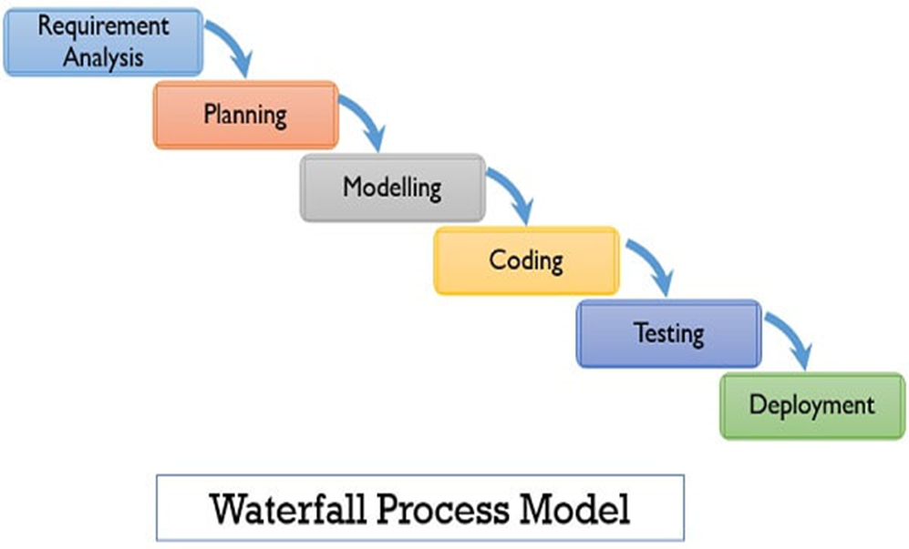
Model Description:

Owing to its cascaded design it is called waterfall model; it is also known as linear sequential model. A conventional waterfall model comprises of five stages: first one is Requirement Definition stage, second is System and Software Design, third is Implementation and Unit Testing, forth is Integration and System Testing and the last one is Operation and Maintenance. Practically, the proposed design flow of the waterfall model is rarely followed. In real projects errors and mistakes of any stage should be traced and report back to the source for necessary amendment and relevant documents should also be updated accordingly. This model is document driven so, it provides sufficient documentation and no stage is considered complete until the documentation of relevant stage is complete. In real life waterfall model-based projects, there exists a feedback loop from any stage to its previous stage. The down side of this model is its late feedback from the end user / customer which comes at the end of project and thus led to time and cost related problems in case of any incompliance, it may cause a threat for concern project.

Spiral Model
Block Diagram for Spiral Model:

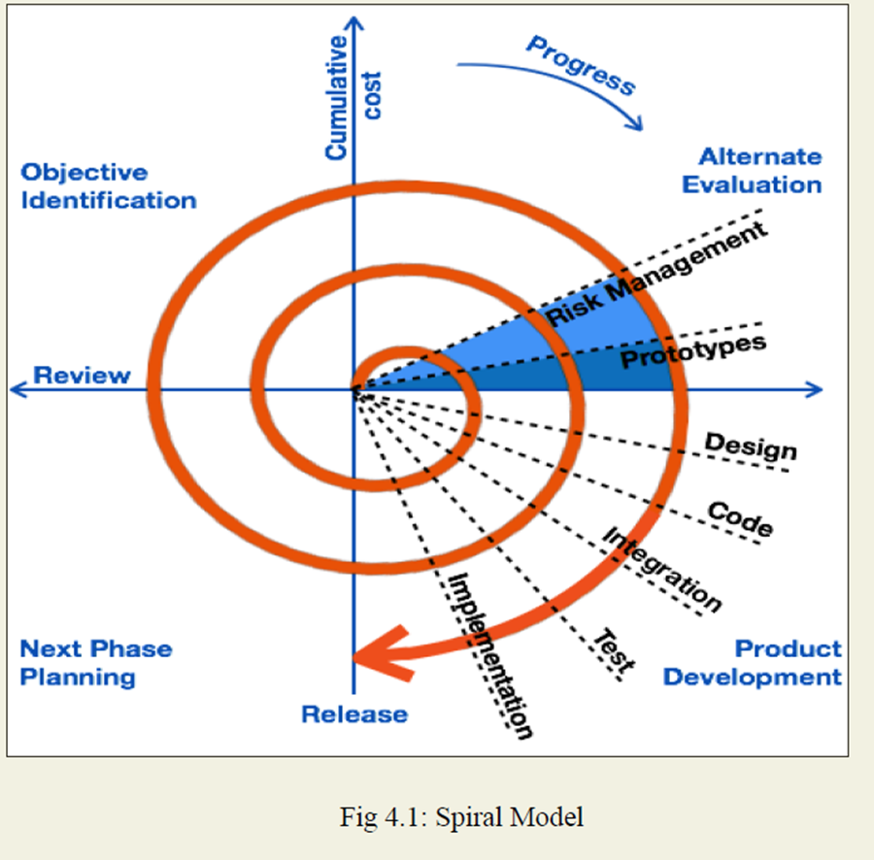

Model Description:

Spiral Model is developed by Barry Boehm and the central idea behind its design is to avert risk as there is always a risk factor in every software development project regarding time, cost and quality etc. This model continuously analyzes risk factors, involved in the project. The main strength of Spiral Model is that it is very sensitive to risk factor. In fact it is a combination of waterfall model plus risk analysis. Here each stage is preceded by identification of alternatives and concerning risk analysis and it is then followed by evaluation and planning for the next phase. If the encountered risks of any iteration cannot be resolved, the project is immediately terminated. There is no distinction between development and maintenance in this approach. It is suitable for only large scale projects. It is also applicable for internal or in house development. As we can see it has two dimensions, the cumulative cost to date, is represented by its radical dimension and progress is shown by its angular dimension.

VU Process Model:

Block Diagram For VU Process Model:
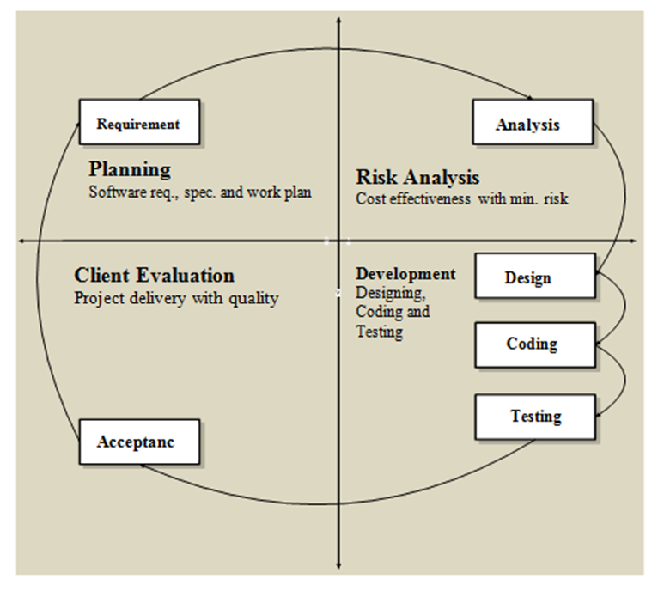

Model Description:

Virtual University of Pakistan suggests its final project students the V.U Process Model which is a combination of Spiral and Waterfall models therefore it combines the benefits of both the models i.e. Waterfall Methodology ensures and exercises strong documentation as it is a sequential and document driven methodology while Spiral Model enforce continuous risk analysis and search for alternatives. These facts make a winning combination when V.U Process Model is used in its true spirit.

Adopted Methodology

As per university guidance, adopted methodology is V.U Process Model. It has a number of salient features that direct the students to work in right direction and in the right way. It provides two strong frame works of product documentation and various risk factors analysis.

Reasons for choosing the Methodology

Combination of both Waterfall and Spiral model is called hybrid approach of system development that maximizes the quality of the system and minimizes the disadvantages and risks. VU process model has four phases which further divides the Waterfall processes. These processes are in iteration until system meets to the department’s requirement.

Work Plan (Gantt Chart):
The work plan is a document that consulting firms use to organize a project. It outlines the plan by which the company plans to complete a quality project within a given amount of time and in compliance with a set budget.
Gantt charts are useful tools for planning and scheduling projects. They allow you to assess how long a project should take, determine the resources needed and layout the order in which tasks need to be carried out. They are useful in managing the dependencies between tasks.
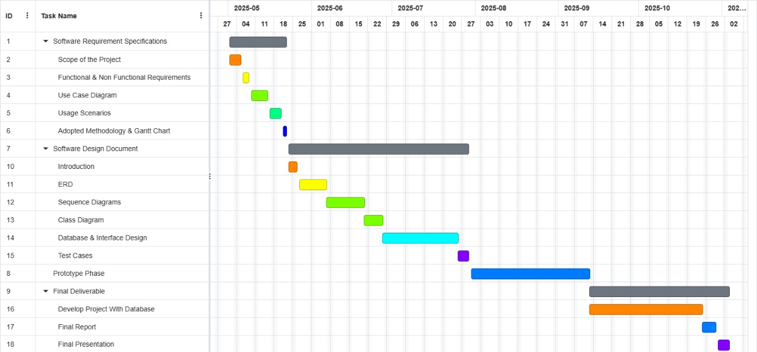

Project Schedule (Submission Calendar):

S No | Task | Start Date | End Date
01 | SRS | Fri 02 May, 2025 | Thu 22 May, 2025
02 | Design Document | Fri 23 May, 2025 | Tue 29 Jul, 2025
03 | Prototype Phase | Wed 30 Jul, 2025 | Fri 12 Sep, 2025
04 | Final Deliverable | Stat 13 Sep, 2025 | Mon 24 Nov, 2025

Chapter 2

Designing the project

Introduction:
The document provides documentation which will be used to aid in system development. The document provides the details of how the software should be built. The design document includes Entity Relationship Diagram (ERD), Sequence Diagrams, Architecture Design Diagrams, Class Diagram, Database Design, Interface design and Test Cases and other supporting requirement information.

Purpose:
The purpose of software design document is to provide a description of design of system fully enough to allow for software development to proceed with an understanding of what is to be built and how it is expected to build. The software design document provides information necessary to provide description of the details for the software and system to be built.

Scope:
The analysis and design phase in software development process is very important as it provide better management and understanding of the requirements. Additionally, system scope, verification and validation are done in analysis and design. Software quality assurance related planning is done in this phase of project.

Definitions, Acronyms and Abbreviations

• HTML (Hyper Text Markup Language)
• CSS (Cascade Styling Sheet)
• DBMS (Database Management System)
• SQL (Structured Query Language)

ERD
ERD is a diagram that shows the relationships between a group of entities stored in a database. In other words, the ER diagram helps to explain the logical structure of a database. ER diagrams consists of Entities, Attributes, and Relationships. ER diagrams have many shapes like: rectangle shape represent entities, ellipses shape define attributes, and diamond shape represent relationships

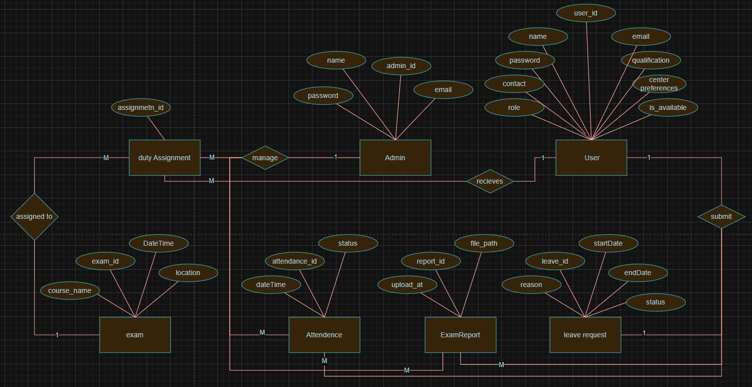

Architectural Representation (Architecture Diagram)
An architecture diagram is a visual representation of the components, relationships, and responsibilities within a software system. It shows the big picture of a software project and outlines the architecture that has been chosen.

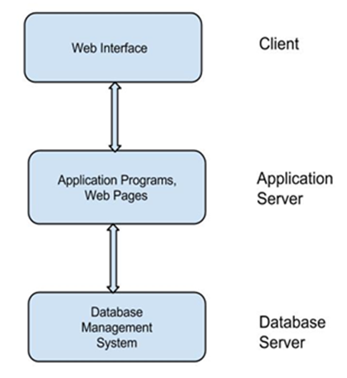

Dynamic Model: Sequence Diagrams:
Sequence diagrams are interaction diagrams that show what messages are sent and when between objects in a system. They are organized by time from top to bottom and by objects from left to right. They are used to represent all the possible interactions in a single-use case. They help to understand how a system achieves a specific goal or function.

- REGISTER:
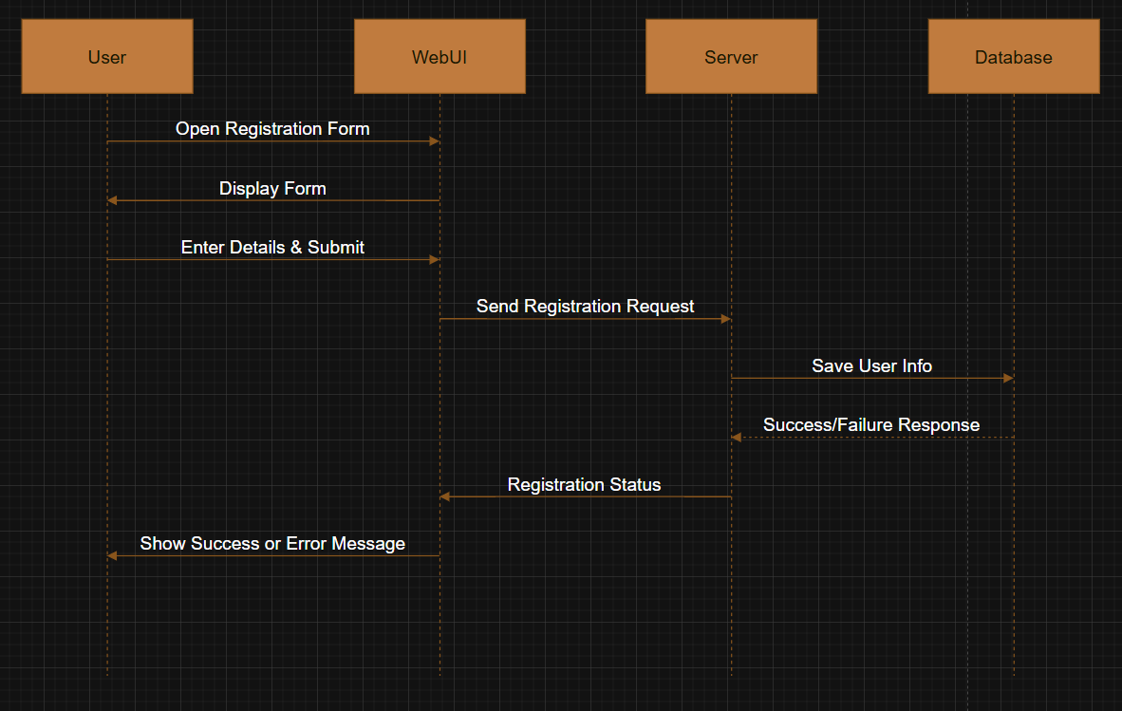
- LOGIN:
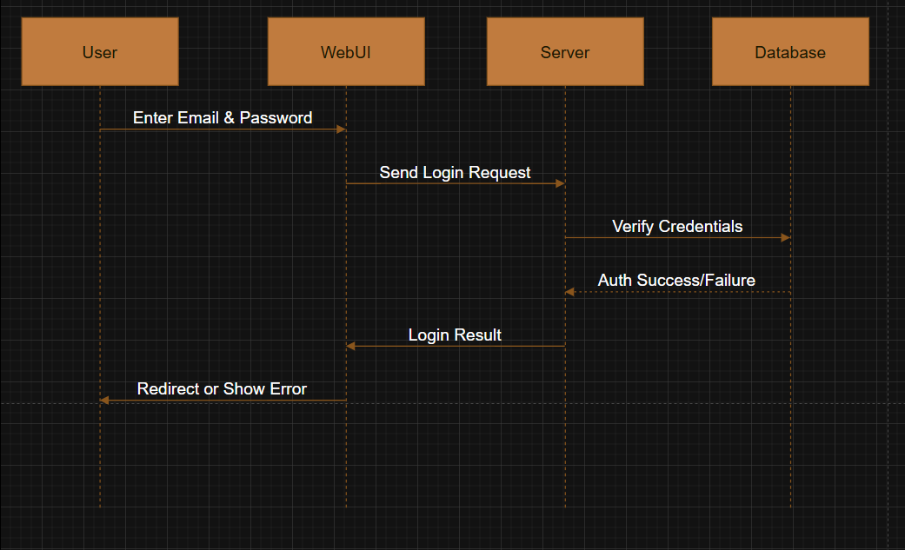
- Mark Attendance:
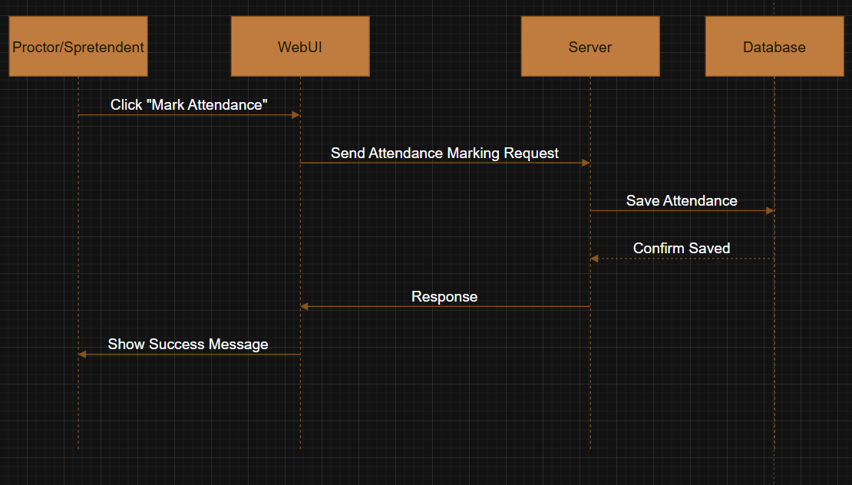
- Upload Report
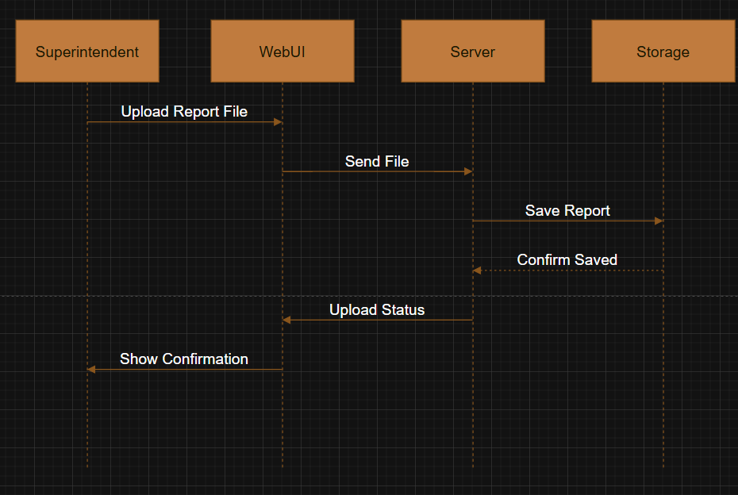
- Leave Request
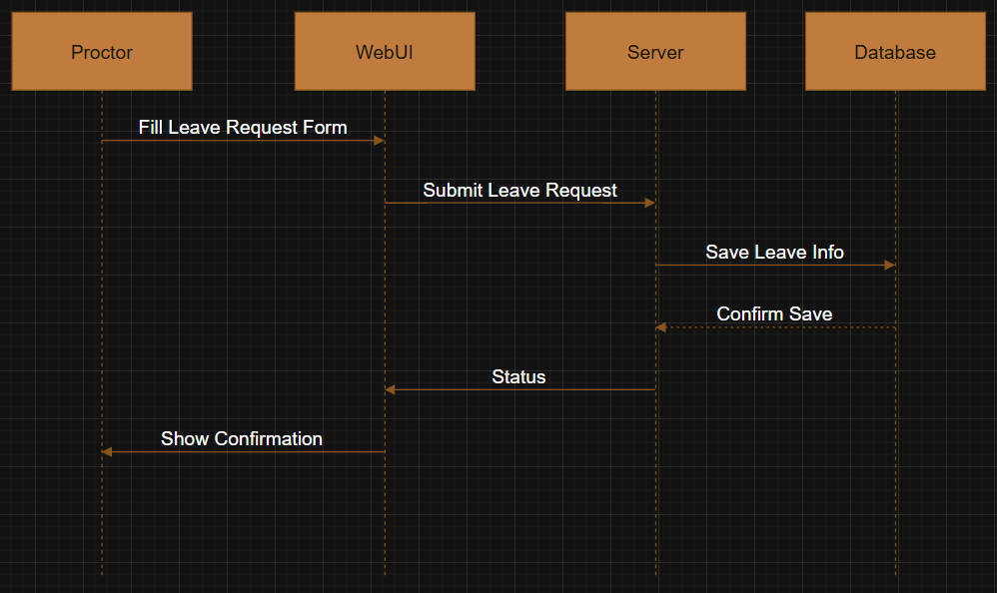

- Update Profile:
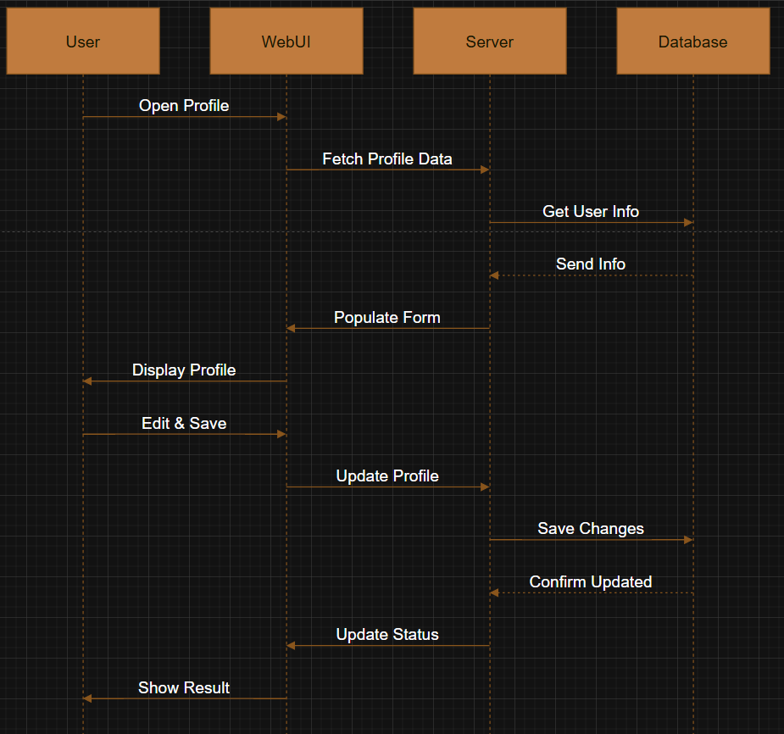
- Duty Assignment:
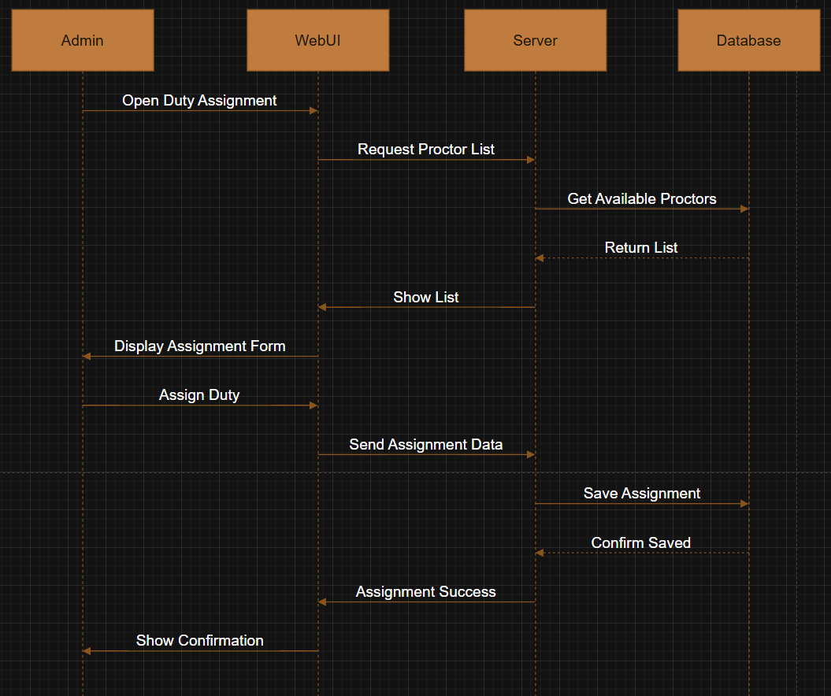
- Manage Attendance:
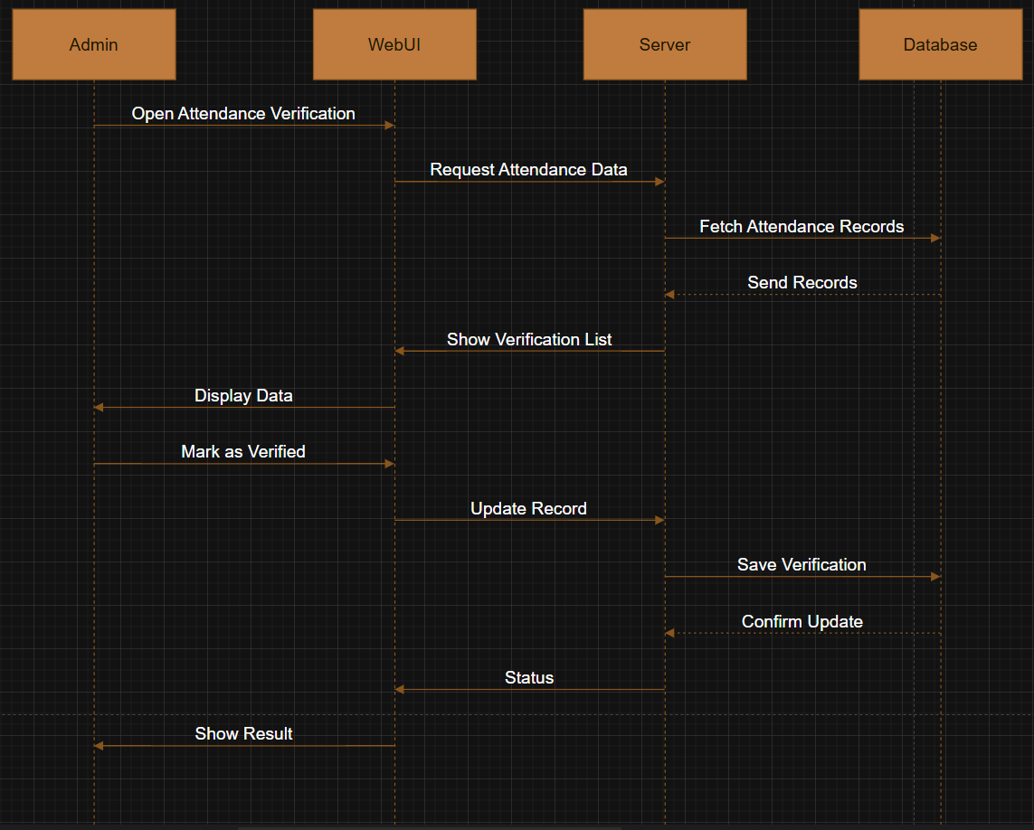

9: make payment:
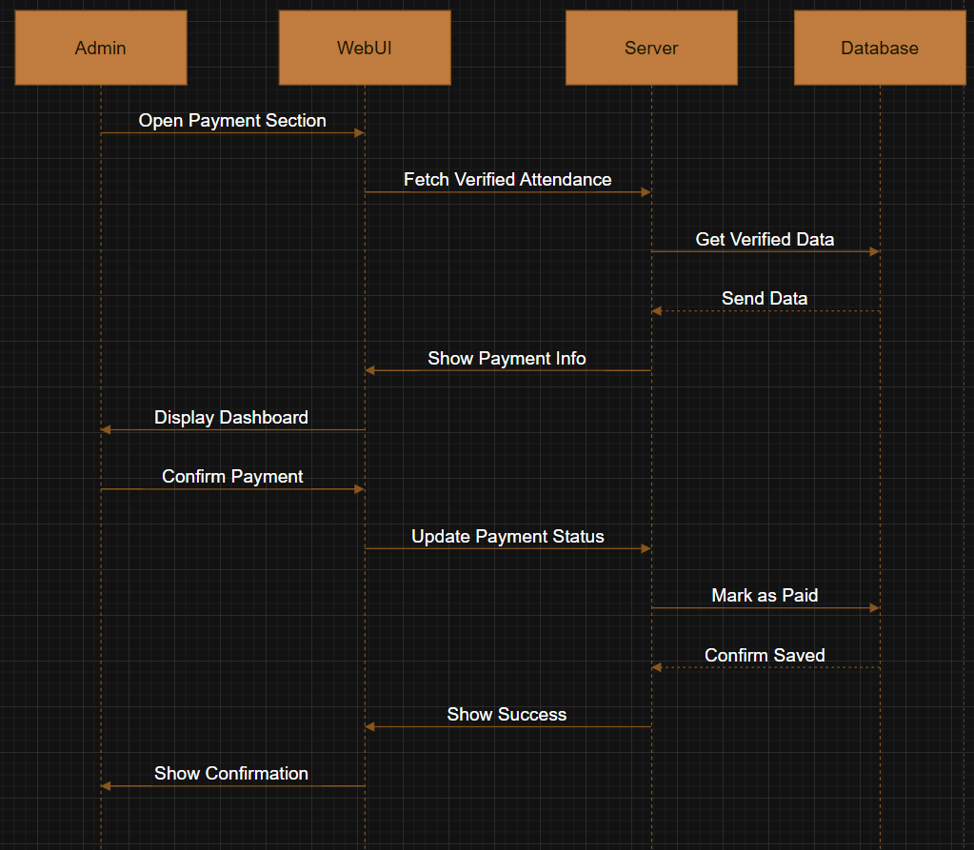

10: manage reports
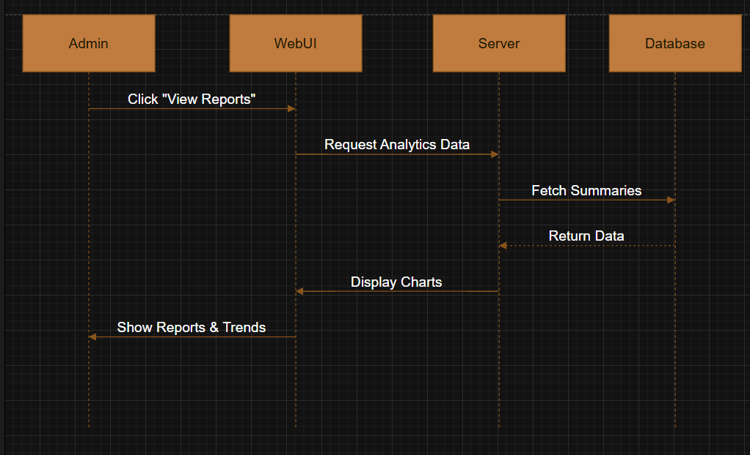

Object Model/Logical Model: Class Diagram:
A class diagram is a visual representation of the objects, attributes, and methods in a system. To create a class diagram, you need to identify the classes and their relationships, and use symbols and lines to show them.

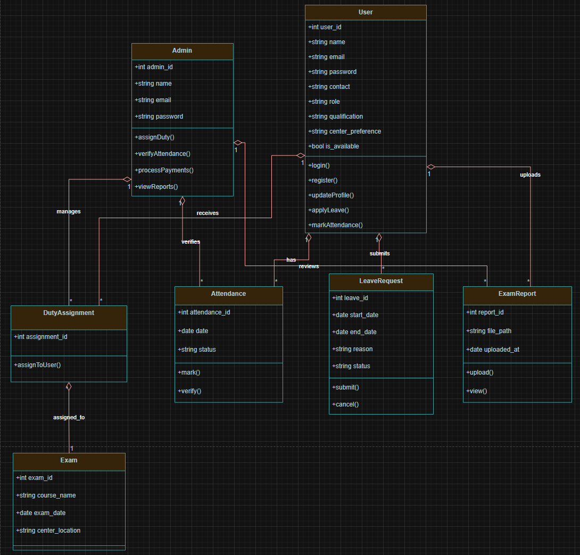

Database Model (Database Diagram):
In a database model, you define the structure of your database, including tables, columns, relationships, and constraints.

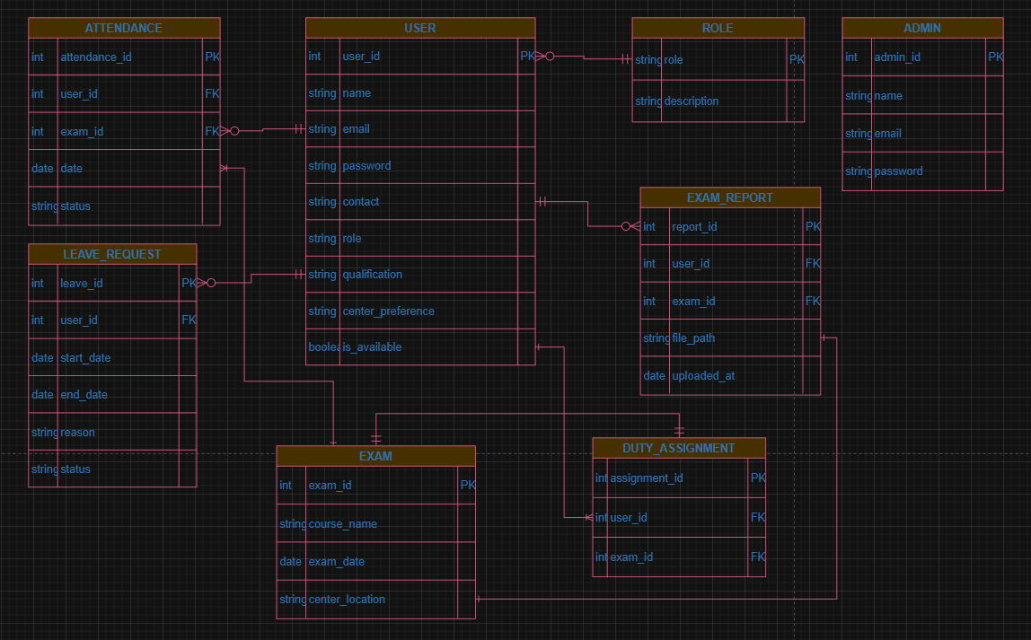

Test Case:
Test Case ID | Use Case | Pre-condition | Action | Expected Result | Result | Tested By
TC01 | Register Account | User must not be logged in. Registration interface should be accessible. | 1. Open registration page.  2. Enter required details and submit form. | New user account is created and saved in the system. | Pass | bc230410624
TC02 | Login | User must be registered and login page should be accessible. | 1. Enter valid email and password.  2. Click login button. | System authenticates and redirects user to dashboard. | Pass | bc230410624
TC03 | Mark Attendance | Actor (Superintendent or Invigilator) must be logged in and have an assigned duty. | 1. Open dashboard.  2. Click 'Mark Attendance' for the current exam duty. | Attendance status is recorded in the database. | Pass | bc230410624
TC04 | Upload Exam Report | Superintendent must be logged in and have completed exam duty. | 1. Go to 'Upload Report' section.  2. Select and upload report file. | Report is uploaded and stored successfully. | Pass | bc230410624
TC05 | Apply Leave | Actor must be logged in. | 1. Open Leave Request section.  2. Enter leave dates and reason, then submit. | Leave request is saved and marked for admin review. | Pass | bc230410624
TC06 | Manage Profile | User must be logged in. | 1. Open profile page.  2. Update contact, availability, or preference fields.  3. Save changes. | Profile is updated in the database. | Pass | bc230410624
TC07 | Assign Duty | Admin must be logged in. | 1. Access duty assignment module.  2. Select exam and assign to available proctor. | Duty is saved and reflected in the user’s schedule. | Pass | bc230410624
TC08 | Verify Attendance | Admin must be logged in. Attendance should be submitted by proctor. | 1. View submitted attendance.  2. Mark attendance as verified. | Attendance is updated to verified status. | Pass | bc230410624
TC09 | Process Payments | Verified attendance records must exist. Admin must be logged in. | 1. Open payment section.  2. Generate and confirm payments. | Payments are marked as processed in the system. | Pass | bc230410624
TC10 | View Reports | Admin must be logged in. | 1. Access analytics/dashboard.  2. Select report to view trends. | System displays charts and reports based on selected data. | Pass | bc230410624
TC11 | Logout | The application interface must be available and any of the actor must be logged in. | 1. Open application interface.  2. Click on Logout button. | Session is destroyed and actor will be logged out from system. | Pass | bc230410624

User Interface
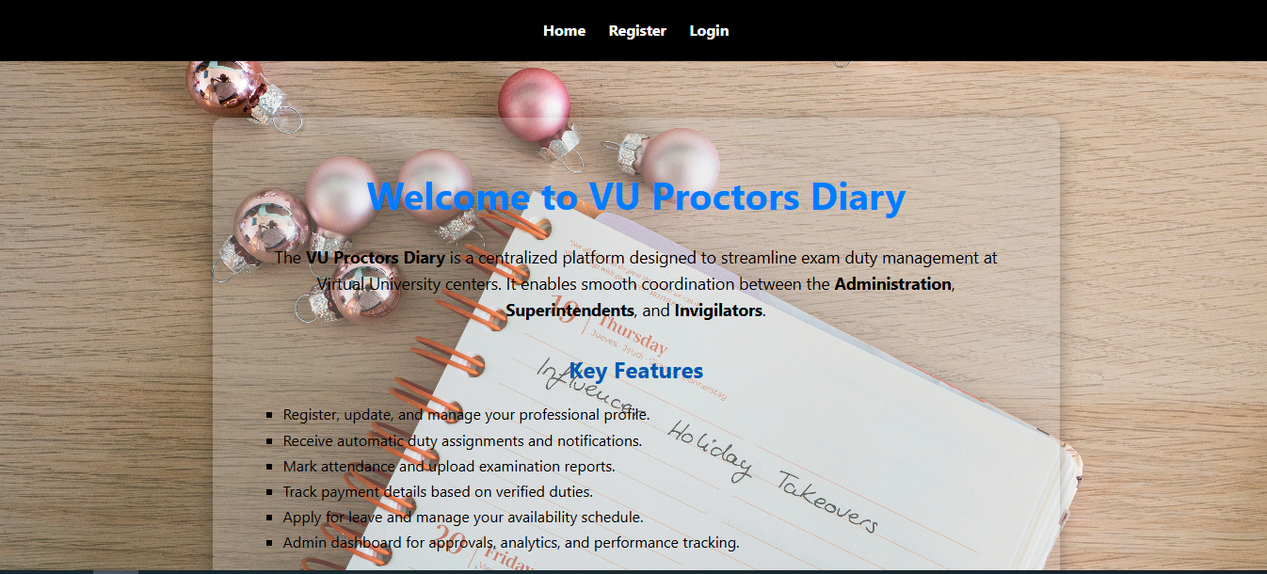

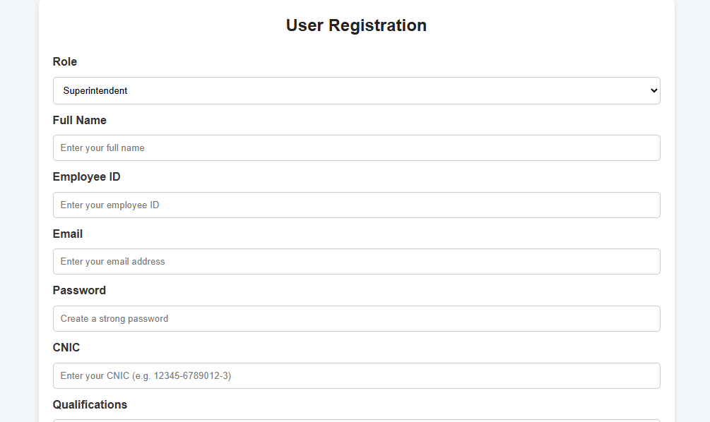
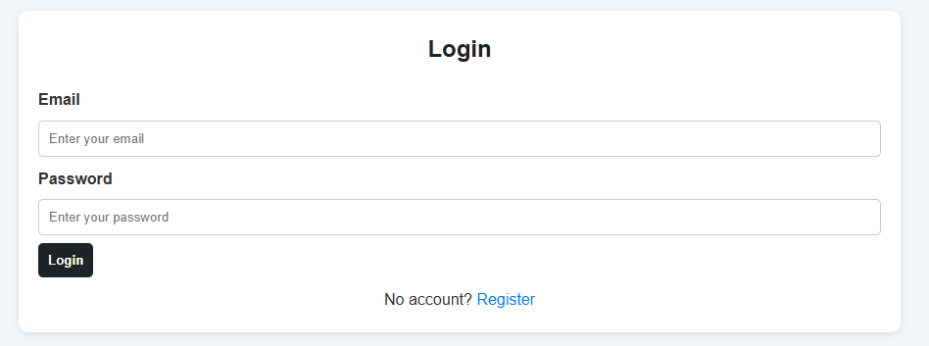
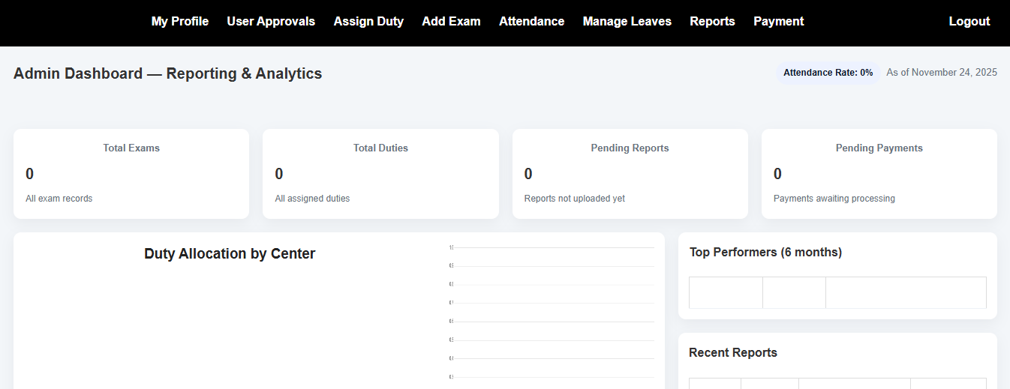

Chapter 3

Development

REFERENCES

Handouts CS504 – Software Engineering – I
Handouts CS5605 – Software Engineering – II
Handouts C403 – DMBS

APPENDIX

Section 1 | Gathering & Analyzing Info
Section 2 | Designing the Project
Section 3 | Development

